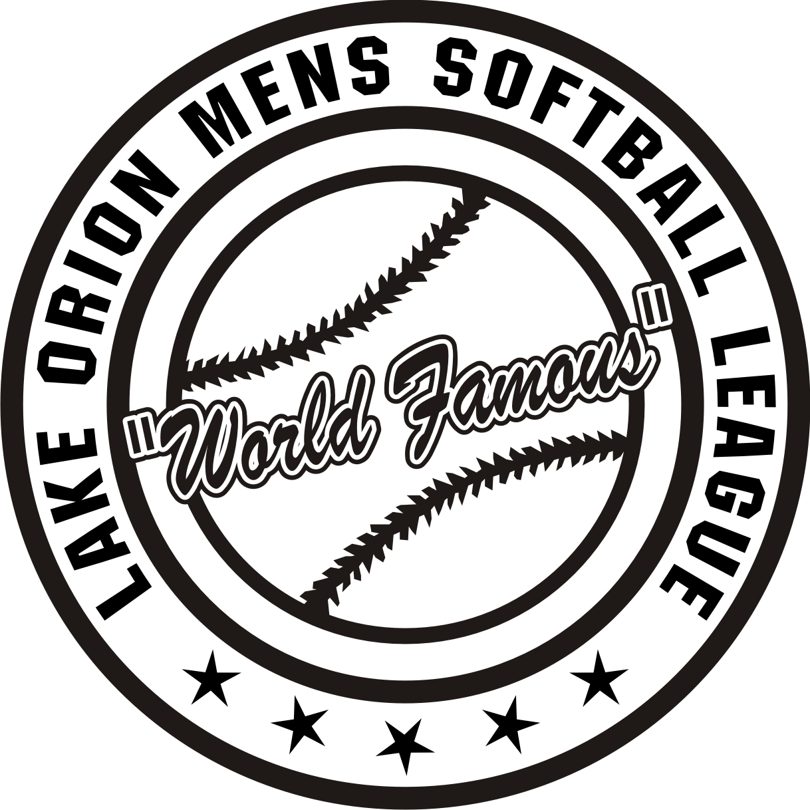

The Lake Orion Men’s “World Famous” Softball League is accepting applications to join this great softball league. This league was formed in 1962 with 4 teams and 54 players and now has 12 teams with over 150 players. This folks is not your ordinary softball league as once you become a member you are a member for life. The only qualifications for this league are as follows:
- Must be 18 years old
- Must be a resident of Lake Orion
Or
Be a graduate of Lake Orion High School

All games are played at the Township of Orion fields and at Friendship Park on Thursday nights. We play a 16 game schedule; have an All-Star game, Pig Roast and an end of the year Banquet. If this sounds like something that would interest you and any of your friends, please get a hold of our Player Representative, Erik Davenport at 248-343-2640 and he will answer any questions or concerns that you have. Don’t have a pen to write down the information, use your smart phone and capture a picture. We hope to hear from you soon as registration will end sometime in February.

